Wheat Rust Diseases
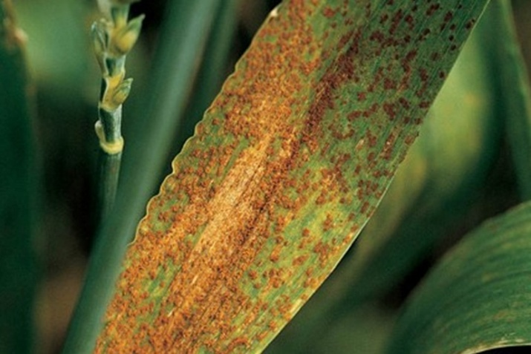
Causal organisms: 1. Wheat Leaf rust, caused by Puccinia triticina, is the most common rust disease of wheat.
2. Wheat stem rust: It is also known as black rust, is caused by the fungus Puccinia graminis and it has recently acquired much attention due to the danger it displays to the global wheat productions in the near future.
3. Wheat yellow rust (Puccinia striiformis f.sp. tritici), also known as stripe rust, is one of the three wheat rust diseases principally found in wheat grown in cooler environments. Such locations are generally associated with northern latitudes or cooler seasons.
The fungus is an obligate parasite capable of producing infectious urediniospores as long as infected leaf tissue remains alive.
Diseases in wheat and other cereal crops worldwide, and they are widely distributed across wheat growing regions. With the capacity to form new strains of fungus, rusts can attack even previously resistant varieties. Rust diseases possess the ability to spread and travel long distances by dispersal of windborne spores and can rapidly develop under optimal weather conditions.
The three rust diseases affecting wheat are leaf, stem and stripe rust. Leaf rust is the most common of the three diseases in the Central Great Plains and other wheat-growing regions in the United States. In some states, leaf rust disease occurs every year. Stem rust is not typically as prevalent as other rusts because many varieties are now resistant to the disease. Stripe rust is becoming an increasingly important disease, with recent outbreaks in the Great Plains states.

Leaf Rust

Stem Rust

Stripe Rust

Managing Wheat Rusts
Farmers have several options to manage wheat rusts, ranging from seed treatments, variety selection, scouting, cultural practices and fungicide applications.

Seed treatments
Using the correct fungicide seed treatment and rate is one way to provide effective and economical disease control in wheat production. Seed treatments protect seed and young plants from disease and other threats to plant health and yield. Areas commonly infested with rust also will need a foliar fungicide treatment to provide protection beyond the seedling growth stage.

Variety selection
Where available, use rust-resistant varieties for best protection against leaf rusts. Every commercially available wheat variety has a unique disease package, and excellent disease resistance is not available to manage all disease threats in high-yielding varieties. It’s best to select two or three high-yielding varieties that offer the best resistance to common diseases found on your individual farm.

Scouting
When scouting for weeds and insects, check for the presence of wheat rusts and other diseases. Monitor reports of wheat rust development occurring in states south of your area. This will allow you to track the progression of rust diseases migrating north from overwintering hosts and will also help you predict the timing and severity of infestations before they might affect your region. Keep a close eye on weather conditions because rust spores spread through wind currents to promote disease infection.
If you suspect leaf rust, stem rust or stripe rust infection, take samples and work with your county Extension agent to confirm a diagnosis. Crop identification guides are also helpful. Scouting helps determine levels of infection so you can make the best decision about the necessity and rate of fungicide applications.

Cultural practices
Disease-free seed gives seedlings a good start. Good weed control preplant, at planting and throughout the growing season also helps protect against disease and other pests.

Fungicides
Good control of wheat rusts can be achieved with commercially available fungicides and proper application timing. The decision to use fungicides should be based on scouting for symptoms. It’s important to assess disease severity from the onset of infection through the various growth stages. Application timing should take into consideration that diseases should be managed before infection reaches the upper leaves. Other factors affecting fungicide application are infection levels in the field, the susceptibility of the variety and the market price for wheat grain.

Crop Science Solutions to Prevent Wheat Rusts
A well-thought-out disease-management program, including best management practices, proper seed protection and selection and fungicide applications using multiple modes of action, should be implemented to sustainably manage diseases. The followingCrop Science solutions are valuable tools to consider for your program.
Because cereal fungal diseases can overwinter and survive in crop residue, crop rotations that include dicot crops can help reduce the inoculum of fungal leaf spot pathogens. Fungicide seed treatments can provide a healthy start for seedlings, especially in cool and damp spring conditions. EverGol® Energy from Crop Science is a seed treatment fungicide that promotes more root growth for faster crop establishment and controls seed and soilborne disease such as Rhizoctonia. It features a new combination of fungicides incorporating a complementary mode of action that supports resistance management.
A number of fungicides are available for both early-season and late-season control of these common leaf diseases. Chemistries from two of the most commonly used classes of fungicides – triazoles and strobilurins – provide good to excellent activity against wheat leaf diseases and, when used in conjunction with best management practices, can help manage disease resistance. Wheat growers should consider fungicides with systemic movement and curative properties for the broadest protection from cereal foliar diseases.
With a combination of two chemistries, Prosaro® fungicide provides preventive and curative action against key cereal leaf diseases such as various types of rust, Septoria leaf blotch, tan spot and powdery mildew. Additionally, Prosaro provides unsurpassed activity against head diseases such as scab (Fusarium head blight) and glume blotch. It’s a good choice to ensure grain quality and enhance yield potential.
For more information on wheat disease control options from Bayer, please contact your local Crop Science representative or visit the cereals section.
Before selecting a seed treatment or applying any fungicide, please read the entire label for the best possible results and to confirm that the product is effective on the disease you need to control. Not every product is suitable for every situation, and correct application technique will ensure the best results.

