Grain smut/Kernel smut / Covered smut / Short smut – Sphacelotheca sorghi
Symptoms
The individual grains are replaced by smut sori. The sori are oval or cyclindrical and are covered with a tough creamy skin (peridium) which often persists unbroken up to thrashing. Ratoon crops exhibit higher incidence of disease.

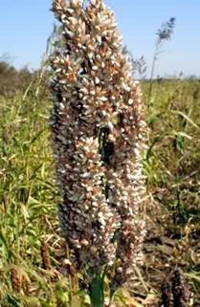 |  | 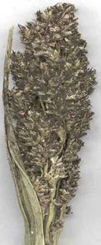
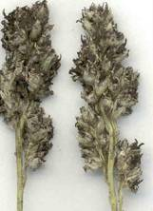 | 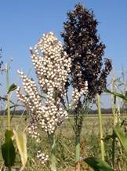

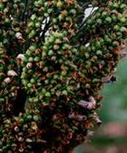
Symptoms

Head smut - Sphacelotheca reiliana
Symptoms
The entire head is replaced by large sori. The sorus is covered by a whitish grey membrane of fungal tissue, which ruptures, before the head emerges from the boot leaf to expose a mass of brown smut spores. Spores are embedded in long, thin, dark colored filaments which are the vascular bundles of the infected head.

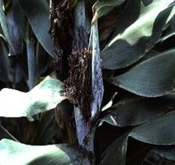
Symptoms

Management for all smuts
- Treat the seed with Captan or Thiram at 4 g/kg.
- Use disease free seeds.
- Follow crop rotation.
- Collect the smutted ear heads in cloth bags and bury in soil.

