Grassy Shoot Disease on Sugarcane
4. 1
Grassy Shoot disease is one of the most important diseases caused byPhytoplasma and affecting sugarcane crop through out its crop growth stages. It is observed in many states of India. This disease causes severe damage to the ratoon crop.
Causal organism: Phytoplasma.

Symptomatology
This disease is characterized by the production of numerous small and thin tillers having narrow leaves with or without albinism.
Diseased plants exhibit varying degrees of loss of chlorophyll, ranging from total green to white. Premature & excessive tillering gives a crowded appearance like ‘grass’ to the clump.
The root system of the affected plant reduced and plants are usually reduced in height (stunted growth). Affected clumps hardly produce one or two weak canes.
In some cases, there is also formation of aerial roots at the lower nodes.
Secondary infection on the full-grown canes shows side sprouting and yellowing.

Transmission
The grassy shoot disease is primarily transmitted through the diseased seed material and perpetuated through ratooning. This disease is also transmitted by a) mechanically by Cutting knife, b) Insects (aphids) and c) Dodder (root parasite).
Control
Adopting one or more of the following measures can minimize the disease incidence.
Use of healthy diseased free planting material collected from seed nursery for planting.
Roguing of affected stools and destruction – Mass eradication may help consistent reduction in inoculum in the area.
Head therapy: seed/planting material should be treated with hot water (50ºC for 120 Min.) or moist hot air (54ºC hr, 2½ hrs.) that eliminates the Pathogen from diseased seed materials. Ratooning of affected crop must be avoided. Crop rotation may be employed to reduce inoculum in the field.
Control of insect pests.
Set treatment with 500-ppm solution of ledermycin (an antibiotic) before planting.

4.2 Yellow Vein Mosaic of Bhindi:
Yellow vein mosaic of bhindi (Abelomoschus esculents) or vein clearing of bhindi most devastating disease in all the bhindi growing regions of India. In case the plants get infected at early stages of development it causes 80% of crop loss.

Symptoms:
The diseased plants can be recognised from a distance due to the yellowing of entire network of veins Fig. 2. The characteristic symptoms of the disease are the homologous network of yellow veins enclosing islands of green tissue within. In severe cases entire leaf become chlorotic.
Infected plants stunted and bear very deformed and small, yellow green fruits. Distortion of leaf stalks and stem occur at the advance stage of infection. The disease cause heavy loss in yield, if the plants get infected within 20 days after germination.

Etiology:
Causal organism: Begomovirus Or Bhindi yellow Vein Mosaic Virus

Disease Cycle:
The disease is transmitted by white fly Bemisia tabaci. The population is high during hot summer months, the crop is seriously affected then. The virus also survives on various weeds growing along the roadside for e.g., Croton sparsifolia, Ageratum etc.

Control Measures:
i. The vectors that are responsible for the spread of virus need to be controlled by spraying dimethoate 0.03 percent or monocrotophos 0.05 at 10 days intervals, (spraying must be done at late hours).
ii. Foliar spray of 5 to 10 ml neem oil in a litre of water at weekly intervals.
iii. Removing and destroying disease affected plants from crop fields to avoid secondary spread.
iv. To destroy the host weeds such as croton.
v. Crop rotation.
vi. Use seeds collected from disease free plants.
vii. Growing resistant varieties for e.g., Akra anamia, Akra Abhay. Punjab Padmini etc.

4.3 Citrus Canker Disease:
Citrus canker disease caused by bacteria.
Introduction to the Citrus Canker Disease:
Citrus Canker is a bacterial disease of worldwide distribution occurring wherever citrus is grown. It is a serious menace to our most valued citrus orchards causing objectionable blemishes on the fruit. The disease causes serious damage in India, China, Japan and Java.
The pathogen incites severe canker disease in a number of citrus species on stems, leaves and fruits. The disease attacks most of the species/varieties of citrus. The most susceptible species are the acid lime plants, the sweet orange and the grape fruit.
Symptoms of Citrus Canker Disease:
Crast-like disease lesions or scabby spots and small cankers (open wounds or dead tissue surrounded by living tissue) appear on all over ground parts of the plant such as leaves, young branches and fruits. The trees are, however, not commonly killed.
The lesions on the foliage, at first, appear on the lower surface as small round raised spots. These are translucent and of yellowish brown colour. Later the spots turn white or greyish and finally rupture. The older lesions are corky and brown, sometimes purplish.
The necrotic brownish canker regions are surrounded by a yellowish brown to green raised margin and distinct watery yellow halo region. The yellow halo region is free from the pathogen. The cankerous lesions contain the pathogen in millions.
Mairie suggested that the halo regions are formed due to the response of the host tissue to a diffusible metabolite of the pathogen. Padmanabhan et al. (1975) reported accumulation of malic acid in the halo region due to increased respiration in this region.
The lesions on the twigs are usually irregular in form. The lesions on the fruit are similar to those on the leaves but lack the yellow halo.
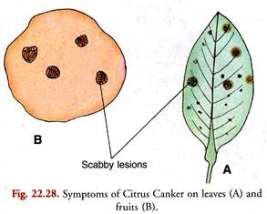
Causal Organism:
The causal organism is the bacterial pathogen Xanthomonas citri, now called X. campestris pv. citri (Hasse) Dowson. It consists of a short, motile rod (1.5-2.0 x 0.5- 0.75 µ) furnished with a single polar flagellum (monotrichous). It lacks endospore formation. It is a gram negative, aerobic form surrounded by a mucilaginous capsule. It forms chains.
The climate factors which favour the disease are the mild temperature and wet weather. The most suitable range of temperature appears to be 20ºC to 30ºC.
Disease Cycle:
Infection takes place through the stomata and wounds. The disease is not soil borne. The pathogen perennates in the old lesions on the twigs still attached to the host plant.
From there it is carried by driving rains and by insects to new localities. Man functions as the chief agent of dissemination by planting infected nursery stock in new localities.
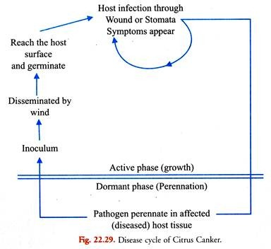
Control Measures of Citrus Canker Disease:
To combat the disease in order to prevent economic loss or to reduce to a low level following measures can be suggested:
1. Eradication:
The disease is controlled by the eradication of diseased trees. This is accomplished by removing the trees with advanced infection and burning them.
2. Pruning:
The infected trees may be cured by removing the diseased foliage and branches with pruning scissors and then spraying the trees with one percent Bordeaux mixture at regular intervals.
3. The use of disease free nursery stock for planting is the best method of controlling the disease.
4. The fallen infected leaves and twigs should be collected and burnt.
5. Spraying:
Spraying with Bordeaux mixture and lime sulphur is a useful measure to protect the fruit. It should be done during the first three months after the beginning of fruit formation. Spraying should commence before the onset of rains and repeated during the rainy season.
6. Citrus nurseries should be raised in places away from the regions of heavy and protracted rainfall. There should be no “khatti” hedge around the nurseries.
7. Rangaswamy (1957) reported that the use of antibiotic sprays is useful in controlling the disease. Streptomycin sulphate and Phonomycin have been found to be effective. Vaheeddudin (1959) found that spraying with neem-cake is effective in controlling citrus canker.

4.4 a) Downy mildew of Pearl millet (Bajara)
Distribution of Downy Mildew
Downy mildew of pearl millet, some times referred to as ‘green ear’ is the most destructive disease of pearl millet. This disease is widely distributed in temperate and tropical areas of the world, and is especially important in India.
Distribution of Downy Mildew
In India, the disease is present in all the states where pearl millet is cultivated. In India, downy mildew epidemics caused substantial yield losses during 1970s and 1980s. Grain yield losses of 10 to 60% have been reported.
Economic importance of Downy Mildew
The yield reducing potential of downy mildew is very high, and this was dramatically recorded in HB 3, a popular hybrid, when pearl millet grain production in India was reduced from 8 million tons in 1970-71 to 5.3 million tons in 1971-72. This reduction was due to a downy mildew epidemic, in which yields in some fields were reduced by 60 to 70%.
Symptoms of Downy Mildew
There is considerable variation in the symptoms, which almost always develop as a result of systemic infection.Systemic symptoms generally appear on the second leaf. Once these symptoms appear, all the subsequent leaves and panicles also develop symptoms. The disease can appear on the first leaf also under conditions for severe disease development .
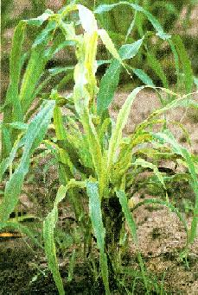 Under conditions of high humidity and moderate temperature, the infection could be very severe. Severely infected plants are generally stunted and do not produce earheads.
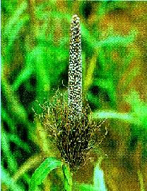
Management of Downy Mildew
Management practices should aim at reducing the movement of primary soil and seed-bearing fungal inoculum, and the secondary spread of the fungus within and between pearl millet fields.
This can be achieved by the possible combination of the 3 disease management practices:
- Cultural,
- chemical, and
- host-plant resistance.
A. Cultural Methods
All cultural methods are aimed at manipulating the environment to the advantage of the host and disadvantage of the disease causing fungus. Five such methods have been suggested to manage the pearl millet downy mildew.
Sanitation
Use disease-free seed and effective removal of disease infested plant material in the field after harvest of the crop are essential to reduce the primary inoculum in the soil.Downy mildew-infected plant material should be burnt, or if feasible the field should be plowed deeply to bury infected the plant material.
Early Sowing
A pearl millet crop sown very early in the season generally has less downy mildew than that sown late in the season. This can be practiced only if sowing is possible with sufficient rains during very early in the season.
Transplanting of pearl millet
A transplanted crop of pearl millet suffers significantly less from downy mildew than a direct sown crop, both in the rainy and post-rainy seasons.Hence, this method can be followed to reduce the downy mildew problem where irrigation facility available.
Roguing
Removal and destruction of infected plants reduces the spread of disease during the same season and also reduces the disease buildup of epidemics during the following seasons. To practice this method farmers should be able to detect infected plants at an early stage. They would have to be convinced that the return from reducing the disease would be worth the extra effort.
Diversification of Cultivars
Growing one hybrid for several years over a large area should be avoided. Instead, if hybrids are to be grown, several of them should be cultivated at the same time within a given area. Growing open pollinated varieties provide another opportunity to keep the disease under control.
B. Chemical methods
The systemic fungicide Metalaxyl was used successfully to control downy mildew in pearl millet. Seed treatment with Metalaxyl 35% at 6 g. Per kg seed controlled the disease excellently for about the first 35 days after sowing.
Foliar application of the Ridouril HZ 72 at 3g per liter arrests further development of the disease in systemically infected plants. If sprayed before floral initiation, disease-free heads are produced.
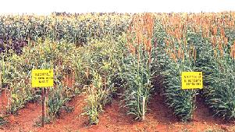
Plots grown without and with seed treatment with Metalaxyl. The untreated hardly produced any heads.
C. Host –plant Resistance
Use of resistant cultivars is the most cost-effective method for the control of downy mildew. Four open pollinated varieties, WC-C75, ICMS 7703, ICTP 8203, and ICMV 155 released in India are resistant to downy mildew.
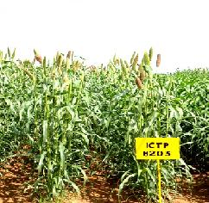

4.4 b) TURMERIC :: MAJOR DISEASE :: LEAF SPOT

Leaf Spot - Colletotrichum capsici
Symptoms
Oblong brown spots with grey centres are found on leaves. The spots are about 4-5 cm in length and 2-3 cm in width. In advanced stages of disease black dots representing fungal acervuli occur in concentric rings on spot. The grey centers become thin and gets teared. Severely effected leaves dry and wilt. They are surrounded by yellow halos. Indefinite number of spots may be found on a single leaf and as the disease advances; spots enlarge and cover a major portion of leaf blade.

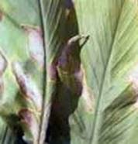 | 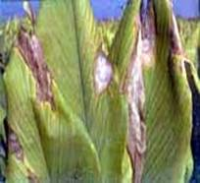
Symptoms
Favorable condition
- The disease is usually appears in October and November
- Relative humidity of 80% and temperatures of 21 – 230C favours the primary infection
Disease cycle
The fungus is carried on the scales of rhizomes which are the source of primary infection during sowing. The secondary spread is by wind, water and other physical and biological agents. The same pathogen is also reported to cause leaf-spot and fruit rot of chilli where it is transmitted through seed borne infections. If chilli is grown in nearby fields or used in crop rotation with turmeric, the pathogen perpetuates easily, building up inoculum potential for epiphytotic outbreaks.
Management
- Select seed material from disease free areas.
- Treat seed material with mancozeb @ 3g/litre of water or carbendazim @ 1 g/litre of water, for 30 minutes and shade dry before sowing.
- Spray mancozeb @ 2.5 g/litre of water or carbendazim @ 1g/litre; 2-3 sprays at fortnightly intervals.
- The infected and dried leaves should be collected and burnt in order to reduce the inoculum source in the field.
- Spraying Blitox or Blue copper at 3 g/l of water was found effective against leaf spot.
- Crop rotations should be followed whenever possible.
- Cultivate tolerant varieties like Suguna and Sudarshan.

4.4 c) Grain smut/Kernel smut / Covered smut / Short smut – Causal organism: Sphacelotheca sorghi
Host : Sorghum vulgare
Symptoms
The individual grains are replaced by smut sori. The sori are oval or cyclindrical and are covered with a tough creamy skin (peridium) which often persists unbroken up to thrashing. Ratoon crops exhibit higher incidence of disease.

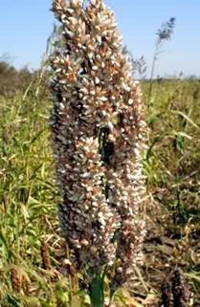 |  | 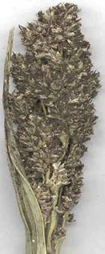
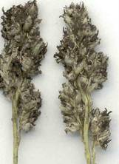 | 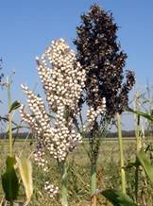

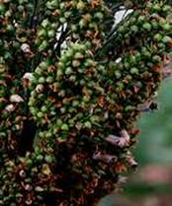
Symptoms

Head smut - Sphacelotheca reiliana
Symptoms
The entire head is replaced by large sori. The sorus is covered by a whitish grey membrane of fungal tissue, which ruptures, before the head emerges from the boot leaf to expose a mass of brown smut spores. Spores are embedded in long, thin, dark colored filaments which are the vascular bundles of the infected head.

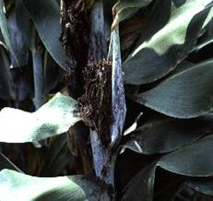
Symptoms

Management for all smuts
- Treat the seed with Captan or Thiram at 4 g/kg.
- Use disease free seeds.
- Follow crop rotation.
- Collect the smutted ear heads in cloth bags and bury in soil.

4.4 d) Anthracnose of bean (Colletotrichum lindemuthianum)

List of symptoms/signs
Fruit - lesions: on pods
Fruit - lesions: scab or pitting
Leaves - abnormal colours
Leaves - necrotic areas
Seeds - discolorations
Seeds - lesions on seeds
Symptoms
Symptoms of anthracnose can appear on any plant part. Initial symptoms may appear on cotyledonary leaves as small, dark brown to black lesions. Conidia and hyphae are transported by rain or dew to the developing hypocotyl. The infected tissues manifest minute rust-coloured specks. The specks gradually enlarge longitudinally and form sunken lesions or eye-spots. These enlarge on the hypocotyl of the young seedling, causing it to rot. On older stems, the eye-shaped lesion is about 5-7 mm. Lesions may first develop on leaf petioles and the lower surface of leaves and leaf veins as small, angular, brick-red to purple spots which become dark brown to black. Later, the lesions may also appear on veinlets on the upper surface of leaves. Sporulation can occur in lesions on the petiole and larger leaf veins, thereby producing secondary inoculum (Zaumeyer and Thomas, 1957). Pod infections appear as flesh to rust-coloured lesions. The lesions develop into sunken cankers (1-10 mm) that are delimited by a slightly raised black ring and surrounded by a reddish-brown border.
The lesion centre is paler, and during periods of low temperature and high moisture, may contain a gelatinous mass of pale salmon pink conidia. With age, the conidia dry up, becoming grey-brown or black. If severely infected, young pods shrivel and dry up. The fungus can invade the pod, and the mycelia and conidia infect the cotyledons or seed coat of the developing seeds. Infected seeds are often discoloured and may contain dark brown to black cankers (Zaumeyer and Thomas, 1957).

Anthracnose of Beans

Introduction
Anthracnose is mainly a seed-borne disease caused by a fungus which has a wide host range on many legume species. This disease can cause serious losses in bean crops in temperate and subtropical zones.

Caused by Colletotrichum lindemuthianum
Host plants / species affected
Cajanus cajan (pigeon pea)
Canavalia ensiformis (gotani bean)
Glycine max (soyabean)
Lablab purpureus (hyacinth bean)
Lens culinaris subsp. culinaris (lentil)
Phaseolus (beans)
Phaseolus acutifolius (tepary bean)
Phaseolus coccineus (runner bean)
Phaseolus lunatus (lima bean)
Phaseolus vulgaris (common bean)
Pisum sativum (pea)
Vicia faba (faba bean)
Vigna mungo (black gram)
Vigna radiata (mung bean)
Vigna sinensis ssp. sesquipedalis (asparagus bean)
Vigna unguiculata (cowpea)

Symptoms
Leaves, stems and pods of bean plants are susceptible to infection. Small reddish-brown, slightly-sunken spots form on the pods and rapidly develop into large, dark-sunken lesions. In moist weather, masses of pink spores develop on these lesions. Black-sunken spots, similar to those on the pods, are produced on the stems and the leaf stalks. Infection of the leaves causes blackening along the veins, particularly on the undersurface.

Biology
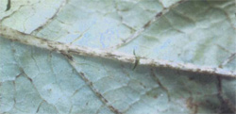
Figure 1. Blackening along the veins of french bean caused by anthracnose

Survival
The fungus can survive on contaminated seed and on crop debris for at least two years.

Dispersal
The fungus can spread by planting infected seed. Rain splash and wind will spread the spores of the fungus within the crop.

Environmental conditions
Development of the disease is most rapid in warm, damp conditions. Symptoms appear between 18-25 °C but are delayed or prevented by temperatures outside the range of 7-33 °C.

Host range
French, mung, and broad beans. There are several races of the fungus. Varieties such as Tweed Wonder, Wellington Wonder, and Redlands Beauty are resistant to the more commonly occurring race but can be severely affected by the other less frequently occurring races.
Prevention and control
Cultural Control
Seed should be pathogen-free. Anthracnose-free bean seed has been produced and used in various regions of the world to control the disease (Costa, 1972; Copeland et al., 1975; Zaumeyer and Meiners, 1975; Crispin-Medina and Campos-Avila, 1976). Infected crop residues should be buried and rotation with non-susceptible crops is often recommended. Crop rotations of 2-3 years are often recommended because the pathogen can survive in infected crop debris for >2 years (Tu, 1983). It is also important to restrict the activity and movement of field workers and agricultural implements in fields when the foliage is wet from rain or dew (Vieira, 1967).
Since the fungus is disseminated in the presence of water, fields should not be entered for cultivation or pesticide applications when the plants are wet. Unnecessary movement in infested fields should be minimised to reduce the spread of the disease. The fungus does not survive well under field conditions, so infested bean debris should be incorporated in the soil after harvest to reduce winter survival. Dillard (1988) recommends two-year crop rotation as insurance against winter survival, as it provides some control of root-rotting organisms.
Figure 2. Black-sunken spots on stem caused by anthracnose
- Use either certified seed, approved seed, or seed known to have a long disease-free history. The use of disease-free seed is the most important control measure.
- Do not plant beans for at least two years in land that has carried an infected crop.
- Remove diseased plants, where practical, to help check the spread of disease.
- Avoid cultivating and harvesting an affected crop when wet to prevent the spread of spores.
- Do not pack lightly diseased pods as anthracnose can develop during transport.

