Classification of plant diseases based on pathogens:
Plant diseases are often classified by their physiological effects or symptoms. Many diseases, however, produce practically identical symptoms and signs but are caused by very different microorganisms or agents, thus requiring completely different control methods. Classification according to symptoms is also inadequate because a causal agent may induce several different symptoms, even on the same plant organ, which often intergrade. Classification may be according to the species of plant affected. Host indexes (lists of diseases known to occur on certain hosts in regions, countries, or continents) are valuable in diagnosis. When an apparently new disease is found on a known host, a check into the index for the specific host often leads to identification of the causal agent. It is also possible to classify diseases according to the essential process or function that is adversely affected. The best and most widely used classification of plant diseases is based on the causal agent, such as a noninfectious agent or an infectious agent (i.e., a virus, viroid, mycoplasma, bacterium, fungus, nematode, or parasitic flowering plant).

Noninfectious disease-causing agents
Noninfectious diseases, which sometimes arise very suddenly, are caused by the excess, deficiency, nonavailability, or improper balance of light, air circulation, relative humidity, water, or essential soil elements; unfavourable soil moisture-oxygen relations; extremes in soil acidity or alkalinity; high or low temperatures; pesticide injury; other poisonous chemicals in air or soil; changes in soil grade; girdling of roots; mechanical and electrical agents; and soil compaction. In addition, unfavourable preharvest and storage conditions for fruits, vegetables, and nursery stockoften result in losses. The effects of noninfectious diseases can be seen on a variety of plant species growing in a given locality or environment. Many diseases and injuries caused by noninfectious agents result in heavy loss but are difficult to check or eliminate because they frequently reflect ecological factors beyond human control. Symptoms may appear several weeks or months after an environmental disturbance.
Injuries incurred from accidents, poisons, or adverse environmental disturbances often result in damaged tissues that weaken a plant, enabling bacteria, fungi, or viruses to enter and add further damage. The cause may be obvious (lightning or hail), but often it is obscure. Symptoms alone are often unreliable in identifying the causal factor. A thorough examination of recent weather patterns, the condition of surrounding plants, cultural treatments or disturbances, and soil and water tests can help reveal the nature of the disease.

Adverse environment
High temperatures may scald corn, cotton, and bean leaves and may induce formation of cankers at the soil surface of tender flax, cotton, and peanut plants. Frost injury is relatively common, but temperatures just above freezing also may cause damage, such as net necrosis (localized tissue death) in potato tubers and “silvering” of corn leaves. Isolated, thin-barked trees growing in northern climates and subjected to frequent thawing by day and freezing by night may develop dead bark cankers or vertical frost cracks on the south or southwest sides of the trunk. Alternate freezing and thawing, heaving, low air moisture, and smothering under an ice-sheet cover are damaging to alfalfa, clovers, strawberries, and grass on golf greens. Legume crowns commonly split under these conditions and are invaded by decay-forming fungi.
The drought and dry winds that often accompany high temperatures cause stunting, wilting, blasting, marginal scorching of leaves, and dieback of shoots. Leaf scorch is common on trees in exposed locations following hot, dry, windy weather when water is lost from leaves faster than it is absorbed by roots. Leaf scorch and sudden flower drop are common indoor plant problems because the humidity in a home, an apartment, or an office is usually below 30 percent. Similar symptoms are caused by a change in soil grade, an altered water-table level, a compacted and shallow soil, paved surface over tree roots, temporary flooding or a waterlogged (oxygen-deficient) soil, girdling tree roots, salt spray near the ocean, and an injured or diseased root system. Injured plants are often very susceptible to air and soil pathogens and secondary invaders.
Blossom-end rot of tomato and pepper is prevalent when soil moisture and temperature levels fluctuate widely and calcium is low.
Poor aeration may cause blackheart in stored potatoes. Accumulation of certain gases from the respiration of apples in storage may produce apple scald and other disorders.
All plants require certain mineral elements to develop and mature in a healthy state.Macronutrients such as nitrogen, potassium, phosphorus, sulfur, calcium, and magnesium are required in substantial quantities, while micronutrients or trace elements such as boron, iron, manganese, copper, zinc, and molybdenum are needed in much smaller quantities. When the supply of any essential nutrient falls below the level required by the plant, a deficiency occurs, leading to symptoms that include stunting of plants; scorching or malformation of leaves; abnormal coloration; premature leaf, bud, and flower drop; delayed maturity or failure of flower and fruit buds to develop; and dieback of shoots.
Symptoms of nutrient deficiencies vary depending on the nutrients involved, the stage of plant growth, soil moisture, and other factors; they often resemble symptoms caused by infectious agents such as bacteria or viruses.
The availability of water may affect nutrient uptake by the plant. Blossom-end rot of tomato, a disease associated with a deficiency of calcium, may occur if the water supply is irregular, even if an adequate amount of calcium is in the soil. This discontinuity in availability of water will inhibituptake of the calcium in a quantity sufficient to nourish a fast-growing tomato plant. Necrosis at the blossom end of the fruit results. This situation generally disappears when water conditions improve.
Excess minerals can damage plants either directly, causing stunting, deformities, or dieback, or indirectly by interfering with the absorption and use of other nutrients, resulting in subsequent deficiency symptoms. A superabundance of nitrogen, for example, may cause deficiency symptoms of potassium, zinc, or other nutrient elements; a lack of or delay in flower and fruit development; and a predisposition to winter injury. If potassium is high, calcium and magnesium deficiencies may occur.
The pH of a soil has a dramatic impact on nutrient availability to plants. Most plants will grow in a soil with a pH between 4.0 and 8.0. In acidic soils some nutrients are far more available and may reach concentrations that are toxic or that inhibit absorption of other nutrients, while other minerals become chemically bound and unavailable to plants. A similar situation exists in alkalinesoils, although different minerals are affected. Oats planted in alkaline soils that actually contain a sufficient amount of manganese may develop the manganese-deficiency disease gray speck. This occurs because an elevated soil pH causes manganese to react with oxygen to produce manganese dioxide, a form of the nutrient that is insoluble to plants.
An excess of water-soluble salts is a common problem with houseplants. Salt concentrations may build up as a whitish crust on soil and container surfaces of potted plants following normal evaporation of water over a period of time. Symptoms include leaf scorching, bronzing, yellowing and stunting, and wilting, plus root and shoot dieback. Damage from soluble salts is also common in arid regions and in regions where ice-control chemicals are applied heavily.
Several nonparasitic diseases (e.g., oat blast, weakneck of sorghum, straighthead of rice, and crazy-top of cotton) are caused by combinations of environmental factors—e.g., high temperatures, moisture stress or poor irrigation practices, imbalance of mineral nutrients, and reduced light.
Environmental disturbances alter the normal physiology of the plant, activity of pathogens, and host-pathogen interactions.

Classification of plant diseases based on symptoms:
The changes in the host plant which serve to recognise the disease are called the signs and symptoms of the disease. The sign of a disease is the external appearance of some portion of the pathogen of the host. It may be some portion of the mycelium of the parasite or some spore stage.
The best examples are the rusty uredosori and black teleutosori of the Stem Rust of wheat, the smut spore stage of Ustilago and white blisters of white rusts (Albugo). These stages of the pathogens are at first covered but become exposed as the spores mature.
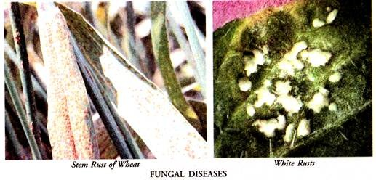
The symptoms are the visible effects which the parasite induces on the host plant. Any visible deviation on the host plant (both physiological and morphological) from the normal in structure and function is called a symptom. Generally the symptoms are growth responses.
These are induced by the causal agent operating on the host. They furnish clues to find out the nature of the disease. Symptoms may affect the whole plant or be restricted to a particular organ or parts of an organ. They are, as a matter of fact, the danger signals of a disease.
The modem plant pathologists do not make any distinction between the two terms (signs and symptoms). They club them together as symptoms of a disease and define the term as external signs on the host plant which are characteristic of a given disease.
These are the result of interaction between the host and the pathogen.
They divide the symptoms of a disease into two categories:
A. Symptoms due to the external appearance of the pathogen or some portion of the pathogen on the host (signs):
The somatic phase in most of the pathogens is usually invisible. It lies within the tissues of the host plant. During the disease cycle some portion of the parasite such as the reproductive or resting structures become visible by rupturing the overlying tissues of the host.
Some pathogens, however, are ectoparasites. In their case both the somatic and reproductive structures are visible externally and furnish a clue to the diagnosis of the disease.
Common examples of such symptoms (signs) are:
1. Mildews:
These are a group of important fungal diseases of seed plants in which the parasite is seen as a superficial growth on the host surface (leaves, green stems and fruits) in the form of patches of varying sizes and colours.
The mildews are of two kinds, downy mildews and powdery mildews. The downy mildews are all internal obligate parasites. They are characterised by superficial downy growth consisting of conidiophores and conidia on the host lesions in damp and warm weather.
The powdery mildews are external parasites in which the mycelium forms whitish patches on the surface of the leaves of the host plant. The patches appear dusty or powdery with the formation of numerous white conidia which form a coating on the host surface.
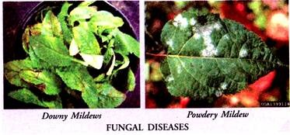
2. Smuts:
These are the fungal diseases of cereals and other members of grass family that cause the ears (particularly the ovaries) to turn black or sooty. The smut symptoms may as well appear on other parts (leaves, stem or roots) of the host plant.
3. Rusts:
These are fungal diseases of grasses and other plants which appear on the host surface as small, coloured pustules-red, brown, yellow, orange, or black in colour.
4. Sclerotia:
The conspicuous phase of some fungal diseases such as Ergot of rye is the formation of sclerotia in the position of kernels in the spike. The sclerotium is a compact, hard mass of dormant fungal hyphae. It may be black, greyish violet, dark brown or purplish in colour.
5. White blisters:
These are white, shining, blister-like pustules found on the leaves of cruciferous plants caused by Albugo Candida, the white rust. These pustules expose the white, powdery masses of spores.
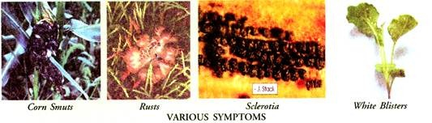
B. Symptoms which are the visible effects induced by the parasite on the host plant:
These are grouped under three categories necrosis, hypoplasia and hypertrophy. The other important symptoms are wilts, and damping off.
1. Necrosis:
Death or killing of the host tissues induced by the attack of a pathogen is called necrosis. It may be caused by rots, blights, wilts, die back and cankers and may be general or local, gradual or rapid. When necrosis is general it is called decay and rotting.
The causal organism may be a fungus or a bacterium. Rotting is universal in plants. It takes a heavy toll of useful plants. The rots are of many kinds. The common ones are dry rots, wet rots, soft rots, hard rots, brown rots, and black rots. These rots cause general necrosis and progress slowly or rapidly.
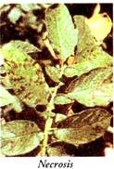
(a) Lesions:
In many cases necrosis is limited in extent. It is confined to small areas and is called local necrosis. It results in localised spots of diseased tissues. These are called the lesions. The tissue in the spot or the lesion area is dead. Examples of local necrosis are leaf and fruit spots.
They are local lesions caused by fungi, bacteria and viruses. The spots are minute, circular or sub-circular and sometimes angular in outline. They are of different colours such as brown, dark, orange, red or white.
The colour of the spot depends upon the nature of fungal spores present in the area. The leaf spot causes reduction in leaf surface and sometimes defoliation. The dead tissue of the leaf spot may fall out leaving circular or irregular perforations. These are called shot holes. The leaf shot holes are sharply bordered.
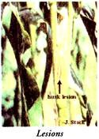
(b) Cankers:
Local necrosis also results in open wounds often sunken in stems and surrounded by living tissue. These are called the cankers. Canker is a dead lesion. Sometimes it is surrounded by a raised margin.
Cankers may be due to slow rots of the outer parts of herbaceous and woody stems. They are thus usually limited in size. They may also be restricted in extent due to the formation of cork around and edges of the wound in the woody plants.
When the canker partly encircles the branch its growth is subnormal. The branch is underdeveloped. If the canker completely encircles the branch the part of the branch beyond the canker dies.
(c) Blight:
In many cases the leaves, stems or twigs, in response to the attack of the pathogen undergo rapid discolouration followed by death. The dead parts become dark or brown in colour. This condition of the affected organ is called the blight.

(d) Rot:
It is a disease in which the affected tissues die and undergo decay. The rot diseases may be classified on the basis of the organ attacked such as leaf, stem or root rots, bud rot and fruit rot. On the basis of type of dissolution brought about by the causal agent, the rots may be classified as soft rot, dry rot, black rot and wet rot.
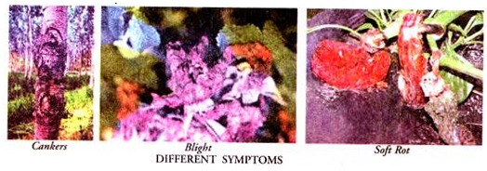
2. Hypoplasia:
It is a subnormal cell production in response to the attack of the pathogen. It results in the subnormal growth of the parts attacked resulting in stunted growth and dwarfing of the host plant.
3. Hypertrophy (overgrowths):
It is an abnormal increase in size of one or more organs of a plant in response to the attack of a pathogen. It results in abnormal growth causing distortions, swellings, leaf curls and galls. The excessive growth may be due to two processes, hyperplasia and hypertrophy.
The former consists in rapid cell division and thus increase in the number of cells of which the organ is composed. Hypertrophy leads to abnormal increase in the size of cells only.
The attack of Com smut stimulates abnormal and rapid cell division (hyperplasia) and enlargement of individual cells (hypertrophy) of the infected organs resulting in the formation of overgrowths called the corn galls or tumours (Fig. 22.6 E).
Witches broom is another result of hypertrophy. It is a compact cluster of fine slender branches generally developing from an enlarged axis and the whole looking like a broom (Witches broom of Cherry). The hypertrophied parts become inedible.
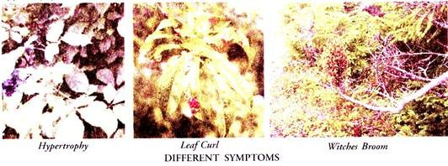
4. Wilts:
The drooping of the entire plant due to loss of turgidity is a common symptom of disease. The causes may be varied. The wilting due to a disease is permanent and eventually leads to death of the plant.
5. Damping off:
Species of Pythium and Rhizoctonia are most important among the fungi which cause damping off disease of seedlings. Either the stem is attacked near the soil level or the crown of roots. The attacked region becomes weak and thus is not able to bear the load of the upper portion of the seedling.
Consequently the seedling collapses. It topples down and dies. The seedling of many plants such as chilli, tobacco, tomato and mustard are prone to the damping-off disease.
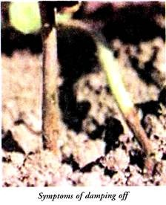

Classification of plant diseases based on type of Crops:
For example;
- Cereal crop diseases,
- Diseases of fruit crops,
- Diseases of vegetable crops,
- Diseases of ornamental plants

Cereal crop diseases:
Sr. no. | Host | Disease | Pathogen
1 | Maize | Grey leaf spot of maize | Cercospora zeae-maydis & Cercospora zeina
2 | Maize | Maize ear rots and mycotoxins | Fusarium and Aspergillus species
3 | Maize | Maize lethal necrosis disease | Multiple virus infections
4 | Pearl millet | Pearl millet downy mildew | Sclerospora graminicola
5 | Pearl millet | Rust of pearl millet | Puccinia substriata
6 | Sorghum | Sorghum downy mildew | Peronosclerospora sorghi
7 | Rice | Bacterial leaf blight of rice | Xanthomonas oryzae pv. oryzae
8 | Rice | Rice blast | Magnaporthe grisea
9 | Rice | Rice yellow mottle disease | Rice yellow mottle sobemovirus
10 | Wheat | - Leaf Rust of Wheat | Puccinia triticina
 |  | Stem Rust of Wheat | Puccinia graminis
 |  | - Stripe Rust of Wheat | Puccinia striiformis
 |  | - Septoria Tritici Blotch of Wheat | Mycosphaerella graminicola
 |  | - Yellow Leaf Spot of Wheat | Pyrenophora tritici-repentis

Diseases of fruit crops:
Sr. no. | Host | Disease | Pathogen
1 | Mango | Anthracnose of Mango | Colletotrichum gloeosporioides
 |  | Sooty mould of Mango | Cladosporium and Alternaria.
 |  | Stem end rot of Mango | Botryodiplodia theobromae
 |  | Bacterial leaf spot of Mango | Xanthomonas campestris
 |  | Crown rot | Fusarium solani
 |  | Fruit rot | Alternaria alternata
 |  | Leaf blight | Bipolaris hawaiiensis
 |  | Rhizopus rot | Rhizopus oryzae
2 | Guava | Anthracnose of Guava | Glomerella cingulata
 |  | Stem canker | Physalopara psidii
 |  | Dry fruit rot | Diplodia netalensis
3 | Papaya | Papaya mosaic | Papaya mosaic virus (PapMV)
 |  | Leaf curl of Papaya | Tobacco leaf curl virus
 |  | Papaya ring spot | Papaya ringspot virus (PRSV)
 |  | Anthracnose of Papaya | Colletotrichum gloeosporioides
4 | Coconut | Leaf blight of Coconut | Cytospora palmarum
 |  | Bipolaris leaf spot‎ | Bipolaris incurvata
 |  | Graphiola leaf spot‎ | ‎Graphiola phoenicis
 |  | Gray leaf blight | Pestalotiopsis palmarum
Diseases of Vegetable crops:
Sr. no. | Host | Disease | Pathogen
1 | Tomato | Damping off | Pythium, Rhizoctonia or Phytophthorathat
 |  | Septoria leaf spot | Septorialycopersic
 |  | Bactrial stem and fruit canker | Cornebacterium michiganense
 |  | Early blight | Alternaria solani
 |  | Fusarium wilt | Fusarium
 |  | Southern Blight | Sclerotium rolfsii
2 | Cabbage | Downy mildew | Peronospora parasitica
 |  | Alternaria leaf spot | Alternaria brassicae
 |  | Frogeye leaf spot | Cercospora brassicicol
3 | Vegetables | Powdery Mildew | Erysiphe polygoni
 |  | Anthracnose | Colletotrichum higginisianum
 |  | Wirestem | Rhizoctonia solani
 |  | Black leg | Leptosphaeria maculans
 |  | Club root | Plasmodiophora brassicae

Diseases of ornamental plants
Plant or crop host | Common name | Type
Aspen | Oak root fungus (Armillaria root rot) | Fungus
Boxwood | Pseudonectria canker (Volutella canker and blight) | Fungus
Boxwood | Volutella canker and blight (Pseudonectria canker) | Fungus
Buckthorn | Branch and twig dieback | Fungus

